Project Design Phase

Solution Architecture
Project Title | DarshanEase: A Smart Temple Darshan Booking System Using MERN Stack
Team ID | ALITS-CSD-2026-DarshanEase
Team Members | Salapala Tharun Kumar Reddy (Team Leader); A. Goutham; M. Siva Prasad; M. Akhila; K. Hemalatha
College | Anantha Lakshmi Institute of Technology and Sciences (ALITS)
Academic Year | 2026

Solution Architecture Overview
DarshanEase follows a three-tier architecture bridging the devotee-facing experience with temple booking operations:
- Presentation layer: React.js single-page application (Vite build) rendering temple listings, booking forms, and the devotee dashboard.
- Application layer: Node.js with Express.js exposing REST APIs for authentication, booking, and journey planning, organized into dedicated service modules.
- Data layer: MongoDB storing users, temples, bookings, and notifications, accessed through Mongoose schemas.
See the accompanying architecture, DFD, ER, use case, activity, sequence, and deployment diagrams generated for this project, which together document how requests flow from the client through the API layer into the database and back.
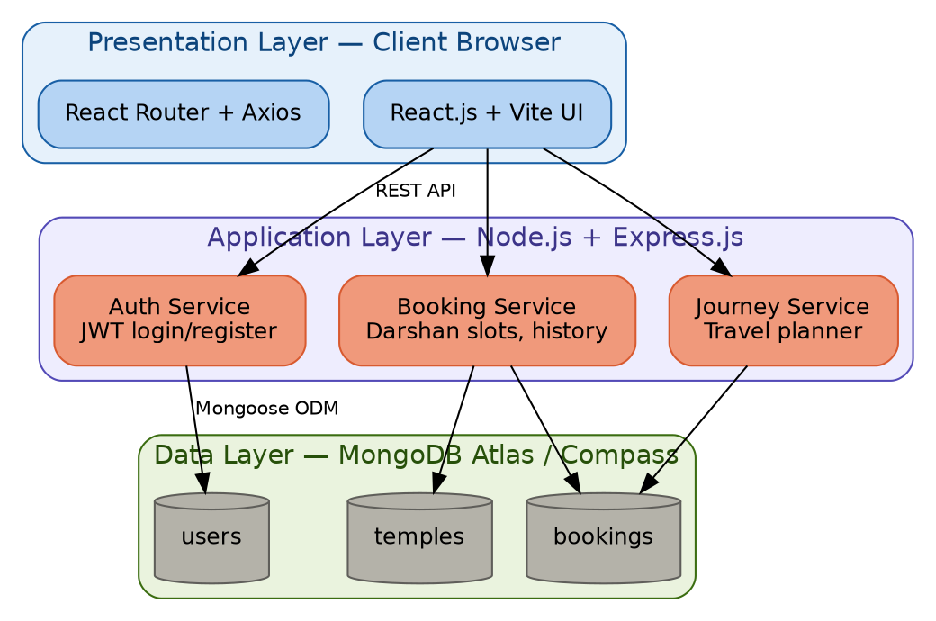
Figure 1: DarshanEase three-tier system architecture
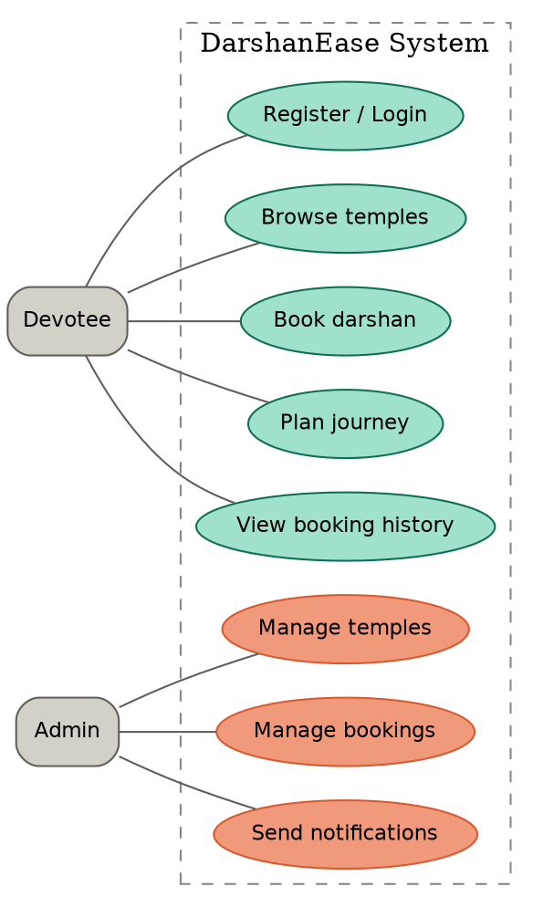
Figure 2: Use case diagram — devotee and admin interactions
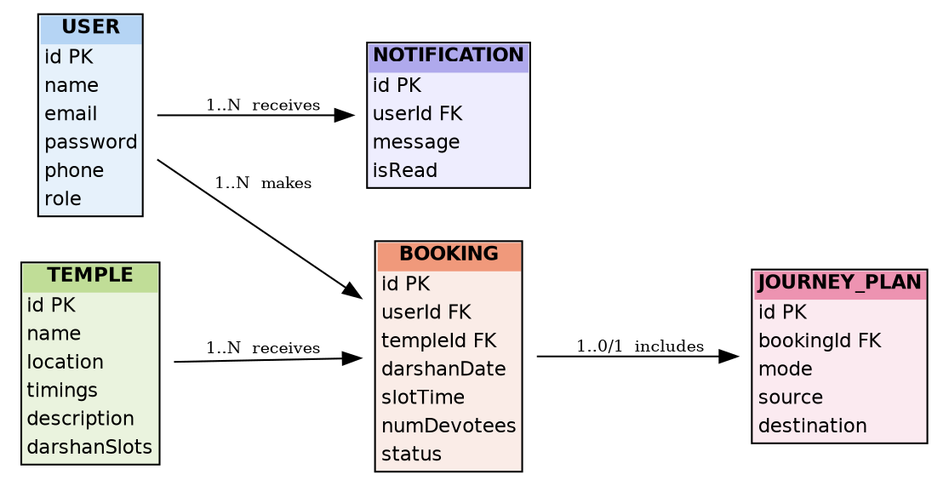
Figure 3: Entity-relationship diagram of the MongoDB collections
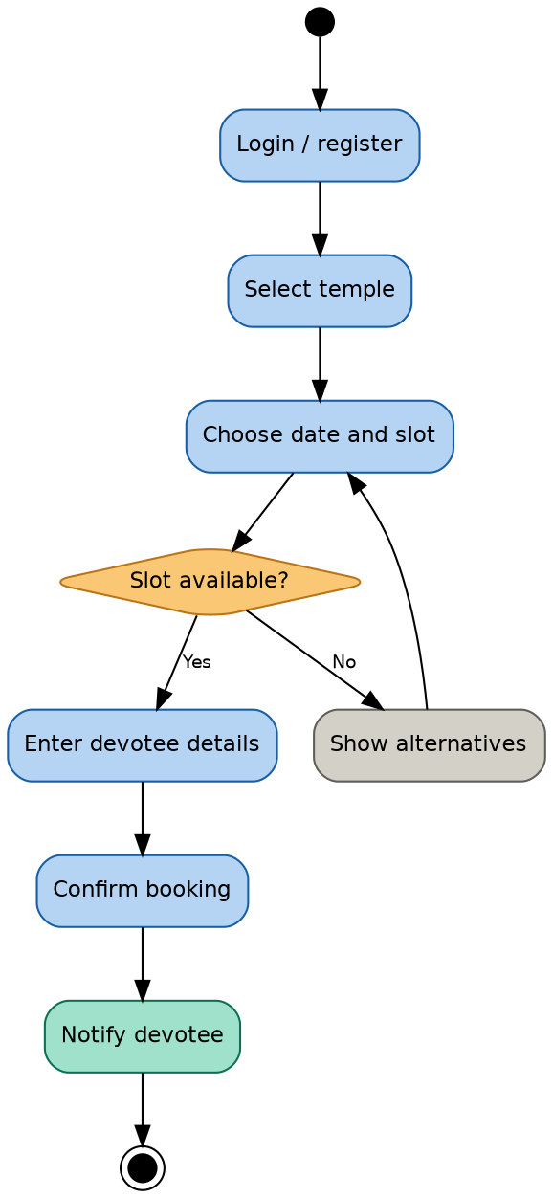
Figure 4: Activity diagram — darshan booking flow
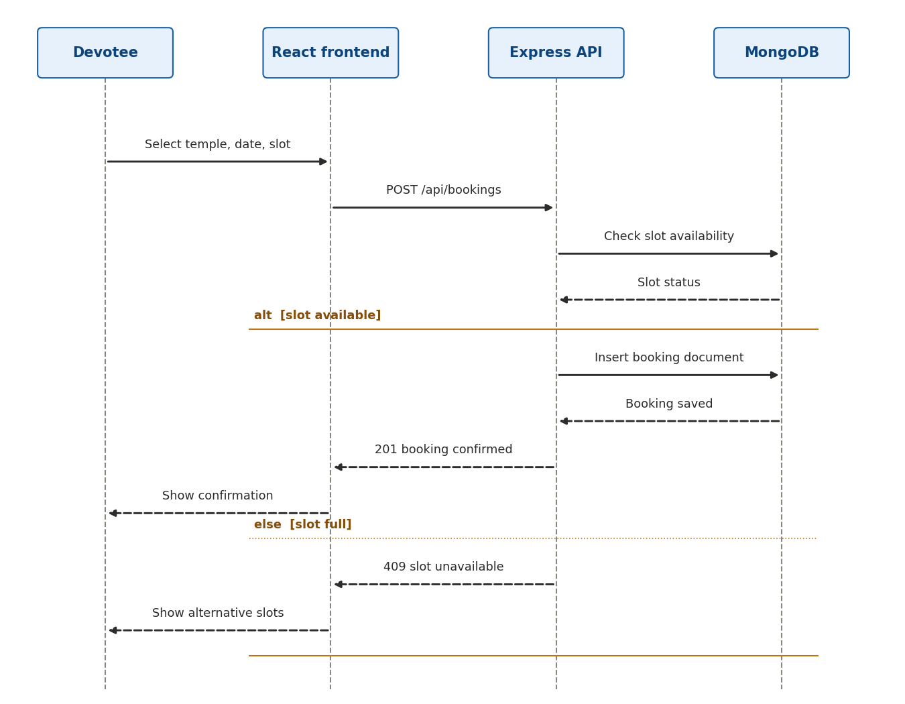
Figure 5: Sequence diagram — booking request through the MERN stack
Figure 6: Deployment diagram — client, application server, and database

Architecture characteristics
S.No | Characteristic | Description | Technology used
1 | Frameworks | Open-source frontend and backend frameworks | React.js, Express.js, Node.js
2 | Security implementations | Authentication and data protection controls | JWT authentication, bcrypt password hashing, HTTPS
3 | Scalable architecture | Clear separation between UI, API, and data tiers enables independent scaling | Stateless REST API, MongoDB Atlas sharding/replica sets
4 | Availability | Minimizing downtime for devotees during peak booking periods | Cloud hosting with managed MongoDB Atlas cluster
5 | Performance | Fast slot lookups and booking submissions | Indexed MongoDB queries on temple and date fields, Vite-optimized frontend bundle

